Topics for Workshopping Narrative

Global Topics of Structure and Arrangement

Step 1: Scene versus exposition (showing versus telling): reading for mimesis

On the way toward distinguishing the conflict that structures a narrative (the controlling and counter ideas—see Step 2), the first step is to read the narrative to simply “get it.” Do your best to let the writing “shine” in its own light, so that you can grasp what the writer intended and can measure that against what they actually accomplished. The writing should bring the reader to have an experience without necessarily being told what that experience ought to be.

To that end, you are to examine to what degree the writer uses exposition to explain and shore up the narrative or to what degree the writer uses in-scene writing to trigger emotional responses in the reader. The more in-scene the writing—“the juxtaposition of uninflected images” in a temporal sequence (Mamet)—the more likely the reader will become involved in the building conflict and then project expectations about what will happen next, and thus remain engaged. Too much exposition—telling the reader what to think and how to interpret the narrative—deflates the conflict and diminishes emotional impact and engagement.

The basic rule: Concerning character, dialogue and location, avoid generalities and let specificity and detail emerge through the action of characters pursing their desires in conflict with who and what opposes their desires (Palahniuk). Providing feedback given by this point of view will help the writer revise to more powerfully impact the addressee.

Note: some exposition is useful and effective, that is, exposition that arises as thoughts and emotions of a character interacting within the scene. We call this kind of exposition “reflection,” or “reflective writing.” After peeling away as much exposition as possible to get to "what happened" in the barest of language, it becomes possible for the writing itself to tell the writer the best ways to use exposition.

Step 2: Articulate the controlling and counter ideas (reading for the context and purpose of the value that controls/dominates the narrative)

After “getting the narrative” through distinguishing exposition from in-scene writing, and amplifying the latter, the workshop group will strive to articulate the dominant controlling and counter ideas that structure the narrative. This step calls for following McKee’s method, where you must look to the last act’s climax to understand what dominates or wins, and then determine what caused or produced this outcome—or what should have caused or produced this or some other outcome, which can only be discovered through exercising this step.

This will always be in two hypothetical statements, one for the counter idea (context) and the contrary for the controlling idea (purpose): the counter idea or “context” is some way of being, doing, or having leads to something unsavory. And that which compensates for the problem the context or counter idea poses: the controlling idea or “purpose” (some way of being, doing, or having leads to something valuable).

The global view of the narrative this step provides is quite powerful, as the insights it grants leads to large-scale revisions.

Step 3: Arrangement

Attending to arrangement builds from step 2, and asks us to look more carefully at the details with this central question: how has the writer structured (or failed to) the narrative to produce a sequence of aesthetic emotions and insights?

Creating a value graph of the narrative is a useful practice to distinguish the structural arrangement of a narrative, which will help to answer the following line of questioning:

Does the conflict progress, that is, grow and build by degrees?

Where are the key moments of reversal (what Butler calls “the rub”)?

If there are no significant moments of reversal, how could the writer build them into the narrative?

How do these reversals affect, or how should they affect the addressee’s mood, moving it from what mood to what mood?

Are the reversals effective and are they progressive?

How could the piece be rearranged effectively?

In terms of structural arrangement, what should be cut, diminished, amplified, or created from scratch because your examination has revealed it to be missing?

Step 4: Close-reading: reading for surprising details that challenge the dominant reading

After distinguishing the value that dominates the narrative, and even controls how the reader interprets the narrative, the next level of workshopping is to be on the lookout for surprising details, following Gallop, that challenge this dominant way of reading the narrative. This workshopping step—where you are to attend closely to words, phrases, sentences, and paragraphs—allows for unforeseen discoveries to be revealed for the workshop group, and especially the writer. The best possibilities to unfold from this part of the process is not to find what should be removed to preserve the dominant reading, but rather to discover new directions the piece might take through seeing previously undisclosed “truths” in one’s writing. That is, once the writer sees these previously hidden truths, revision becomes possible.

Essential to close-reading is to articulate an opposing controlling value, that is, the value against which the dominant value (from step 2) struggles, which value must occur in a negative light cast by the dominant value, if the dominant value is to remain as such. In other words, when the writer/reader is beholden to a particular value, the value determines how the writer projects, and so will likely lead to not seeing what would surprise or challenge the writer/reader. Again, this opposing controlling value will be in two hypothetical statements, though inverted somewhat in relation to the dominant value. Here’s an example:

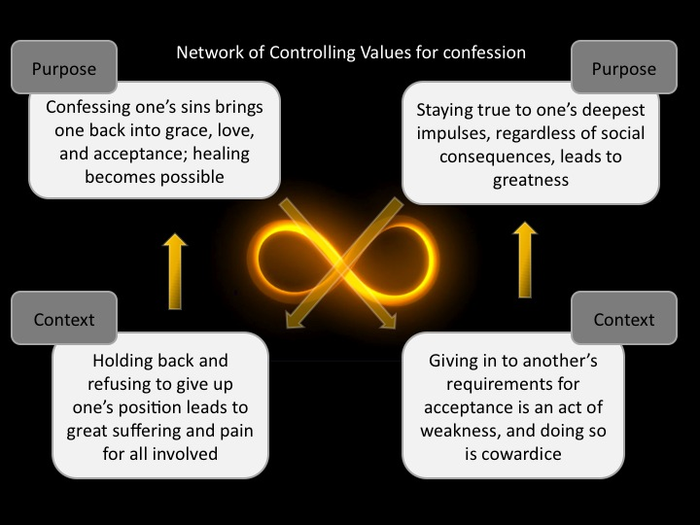

Carefully attending to surprising details allows the opposing controlling value to emerge, and in the process, new levels of conflict become possible, which the writer can then bring into the narrative at various levels, from the global (steps 1-5) and the local (steps 6-7).

Step 5: Reading the relationship between the narrator and addressee

Close-reading opens the door to the next workshopping step: to “see” to what degree the writer has the character-narrator consistently speaking from the narrative present about the past being narrated. Another way to approach this is to ascertain to what degree the writer has created a persona that is not necessarily identical to the writer, which persona addresses an addressee that may not necessarily be the reader. Here we must ask challenging questions:

How does the narrator work to bring the addressee to adopt the dominant value of the piece, relinquishing her own values to do so?

Does the writer succeed in the attempt or not?

Where is it successful and where isn’t it?

What revisions would make the attempt more successful?

Local Topics of Style: Tropes and Schemes

Step 6: Reading for rhetorical tropes

Tropes are figures of speech that “turn away” from common usage and meaning. The four master tropes are:

Metaphor, where a word is transferred, carried over, from its proper meaning to another, by creating a similarity between two dissimilar things: “Procrastination is dancing after the song has ended.”

Metonymy, where the effect stands in for the cause, or vice versa, or a thing stands in for an associated, contiguous thing: “It seems that today I have forgotten my pen.”

Synecdoche, where a part of a whole stands for the whole, or the whole stands for the part: “I have spilled too much ink on Nietzsche’s essay “On Truth and Lying in a Nonmoral Sense.”

Irony, where the writer enacts an inversion or reversal of expectations, which requires two audiences: an authorial audience who sides with the author, who sees and gets the irony, and a narrative audience who only sees the narrator, and who misses the irony: “I adore those neighbors who throw parties late into the week nights, and I especially love those who let loose partygoers who then storm the streets hurling slurred speeches out loud and into the ears of those trying to sleep.”

Here are a few other important tropes to look out for and practice in your writing:

Anthimeria: substituting one part of speech for another: “Friend me!”

Antonomasia: using a descriptive phrase instead of a proper noun

Hyperbole: overstatement

Litotes: understatement: “I am not unmoved when the vulnerable suffer”

Paranomasia: punning

Periphrasis: replacing a single word with a string of words

Onomatopoeia: the sound of the word imitates what it names

Tmesis: a word broken up into pieces: “fan-freaking-tastic”

Apostrophe: addressing a person or object not present

There are many more tropes to explore and practice.

Step 7: Reading for rhetorical figures: schemes

The text Copy and Compose is helpful as a starting place, and here are a few notable schemes:

Schemes of balance:

Parallelism: the presentation of two or more ideas of equal importance using a similar grammatical structure

Isocolon: grammatically parallel presentation of two ideas of equal length

Antithesis: contrasting words or phrases placed side by side in parallel structure

Chiasmus: Grammatical structure repeated in inverted order in second half of a sentence, where the first half has two parts

Schemes of emphasis:

Zeugma (as ellipses): using a single noun or verb with several verbs or nouns

Asyndeton: succession of phrases or clauses without connective conjunctions

Polysyndeton: succession of phrases or clauses connected with conjunctions

Anastrophe: inverted word order. “Let’s speak of all things literary”

Schemes of repetition and restatement:

Anaphora: First word of successive clauses or sentences repeated

Epistrophe: Last word of successive clauses or sentences repeated

Symploche: First and last words of a clause or sentence repeated

Anadiplosis: word that ends clause/sentence begins next

Conduplicatio: beginning a clause/sentence with key word from previous

Antimetabole: Two terms of the first half of a sentence are repeated in the last half in inverted order: AB:BA

Parentheses: Word, phrase, or clause inserted as an aside in the middle of a sentence

Ploche: repetition of same word with different senses

Polyptoton: repetition of different forms of same word: “Your inventory is made up of all the things you have already invented”

Climax: presentation of ideas in increasing order of importance

Schemes of transition:

Metabasis: transitionary summary that recaps what came before and hints at what is to come

Procatalepsis: heading off objections in advance

Analepsis: flashback

Metalepsis: attributing present effect to a distant cause (“the butterfly effect”)

Hypophora: Questions and answers

